Automatic I-Type Carton Sealing Machine
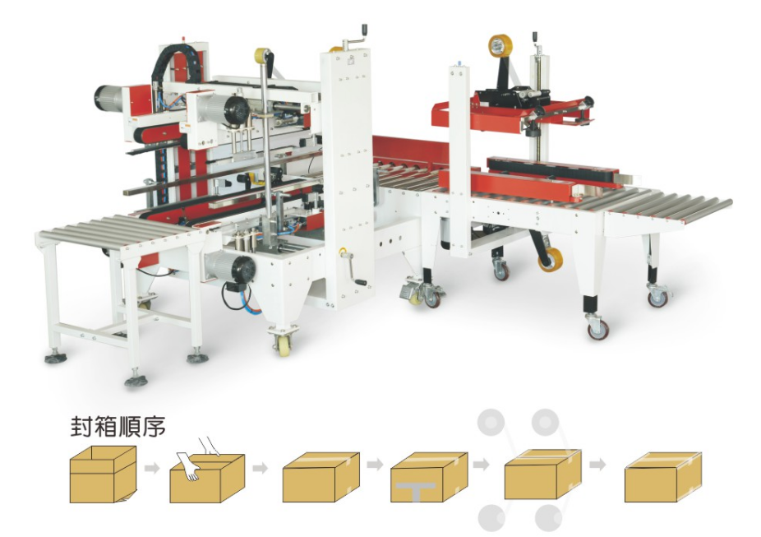

Basic use：
It is suitable for sealing and packaging of the same specifications. It is matched with the automatic packaging machine to realize automatic sealing, which greatly saves labor, reduces labor intensity and improves production efficiency.

Equipment advantages:
- It is suitable for batch use of the same size carton at the same time, and manually adjust the width and height when changing the size.
- Automatic folding cover "one" type box sealing machine is used together with "I" type box sealing machine on four corners to form an I-shaped box sealing machine.
- The structure of the tape holder is precise and firm, the operation is soft and the service life is long.
- This machine can be operated alone or combined with unmanned automatic strapping machine and conveyor to form an automatic sealing, strapping and packaging production line. The instant adhesive tape seals flat, firm, standardized, and beautiful, and will not tear the box.

Main Technical Parameters：
mode | Carton Sealer ZRL-FC500 | L-Type Semi-Automatic Side Sealer ZRL-FG500L
Voltage power | AC200-240V 50/60HZ 0.2KW | AC200-240V 50/60HZ  0.6KW
Package dimensions | L(200-580)mm*W(120-480)mm*H(120-480)mm | L(340-700)mm*W(200-500)mm*H(180-500)mm
working pressure | 4kg/cm2 | 5kg/cm²
speed/min | 10-15（m/min） | 6-10（m/min）
Machine size | L1700mm×W900mm×H1510mm | L1950mm×W1150mm×H（Countertop height800）
Sealing tape width | 48mm、60mm、70mm | 48-72mm
net weight | 200kg | 450kg

Configuration Parameters：
Model | Carton Sealer ZRL-FC500 | L-Type Semi-Automatic Side Sealer ZRL-FG500L
Motor | Taibang | Taibang
PLC Control |  | Customized
Contactor | Schneider | Schneider
Intermediate Relay |  | Schneider
Push Button Switch | APT Siemens APT | APT Siemens APT
Pneumatic Cylinder | Airtac | Airtac

